F1 Podium Prediction — Milestone 1 Analytical Report

Overview
Our final model, XGBoost, ranks podium finishers with a test PR-AUC of 0.593 and ROC-AUC of 0.909, against 0.502 PR-AUC for a grid-only baseline. It uses only information known after qualifying and before the race starts.
- Task: for every driver in every race, predict whether they finish on the podium (positionOrder <= 3).
- Data: the Kaggle / Ergast Formula 1 World Championship (1950–2024) dataset, 14 relational tables, joined into one modeling table of 24,921 driver-race rows from 1,114 races (1950–2024).
- Cutoff: after qualifying, before the start. Current-race results, status, points, laps, pit stops and post-race standings are never features.
- Base rate: 13.5% of rows are podiums after cleaning, so PR-AUC is the primary metric.
- Models: logistic regression, random forest, XGBoost and a shallow neural network, all on the same rows and 30 features. All four land within 0.011 test PR-AUC of each other; starting position carries most of the signal.
The full analysis, with every plot and experiment, is in the run-all notebook milestone1 Notebook.ipynb. Section numbers in this report refer to that notebook.

Data cleaning and grain
After cleaning, results has exactly one row per (raceId, driverId), every key reconciles, and the podium rate rises from 12.7% to 13.5% because the removed rows were almost never podiums. Raw CSVs are never modified; all cleaning runs on copies (notebook sections 1–2).
Step | What we did | Why
Sentinels (2.1) | Replaced the text \N with real missing values in all 14 tables | pandas does not treat \N as missing
Semantic typing (2.2) | Dates to datetime64, times of day to datetime.time, lap and race times to float seconds; gaps such as +5.478 added to the winner's time | Durations become comparable numbers; converted finish times match milliseconds in 7,651 of 7,680 rows
Keys (2.3) | Checked every primary key (unique, non-null) and 23 foreign-key links | All primary keys valid, zero orphan rows
Indianapolis 500 (2.4) | Removed the 11 Indy 500 races (1950–1960) and subtracted their points from the standings | Only 3 of its 107 drivers raced a normal Grand Prix; 99.8% American entrants; about 37 cars per race against 22
Failed to qualify (2.5.2) | Removed 1,368 F rows | These drivers never started; none was ever a podium
Grid 0 (2.5.2) | grid_numeric places them behind the last starter; non_standard_start flags them | Left as 0 they would look ahead of pole
Mostly empty columns (2.5) | Dropped session dates and times, post-race timing, q2/q3, driver number/code, and pit_stops.duration | 44–99% missing (duration is an exact copy of milliseconds); a correlation check with podium before each drop
Shared drives (2.6) | Removed 65 duplicate rows; flagged 175 rows shared_drive = 1 | Needed for one row per driver per race
Correlation check before each column drop. Schedule columns in races and driver number/code correlate between −0.06 and +0.01 with podium, so they are both mostly empty and unrelated. The post-race results columns are strongly related (position −0.65), which is exactly why they are leakage and must go. For q2/q3, whether a value exists correlates up to −0.32 with podium, but the kept qualifying position already carries that signal more strongly (−0.49).
Duplicate rule (shared drives, mostly 1950s). When a driver appears twice in one race, we keep the row of the car they finished in, with that car's grid and result, and never mix columns from two rows.
- Takeover (44 pairs): the driver's own car broke and they took over a teammate's car. We keep the taken-over car, the result they were credited with.
- Swap (17 pairs): drivers exchanged cars. The lowest resultId of a car belongs to its starter (true in 36 of 40 checkable cars), so the driver's later-added row marks the car they finished in.
- One driver, two cars (1 pair): Hernando da Silva Ramos, 1956 French GP; we keep his regular Gordini entry.

Question 1: front-row conversion by circuit
Answer. Among circuits with at least 5 races, Circuit of the Americas, Sochi and Magny-Cours convert a front-row start into a podium most often (above 80%). The ranking changes completely after 2014: over the 16 circuits with enough starts in both eras, the Spearman rank correlation is −0.03 (p = 0.91).
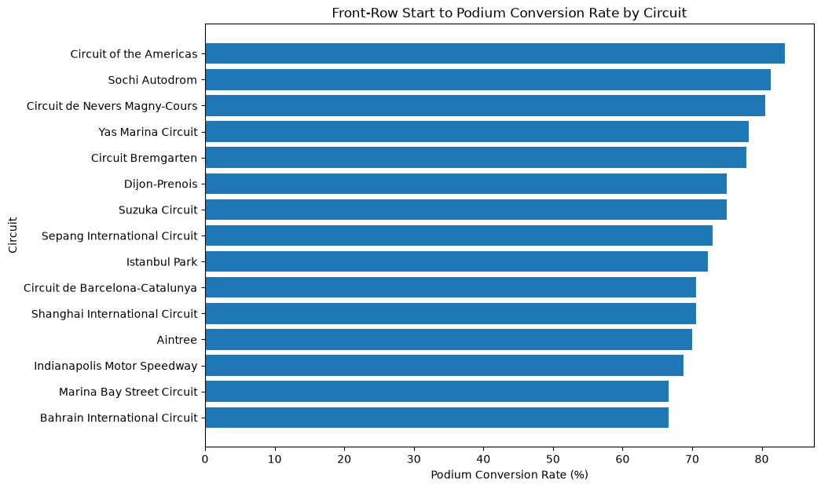
Does the ranking change after 2014? Yes. Only Suzuka and Barcelona stay in the top 5. Monaco rises from 15th to 3rd (49% to 85%), while the Hungaroring falls from 2nd to last (68% to 59%). Each circuit has only 10–30 front-row starts per era, so most single moves sit inside their 95% intervals; only Monaco's change is larger than its uncertainty. The safe conclusion is that the pre-2014 ranking does not carry over.
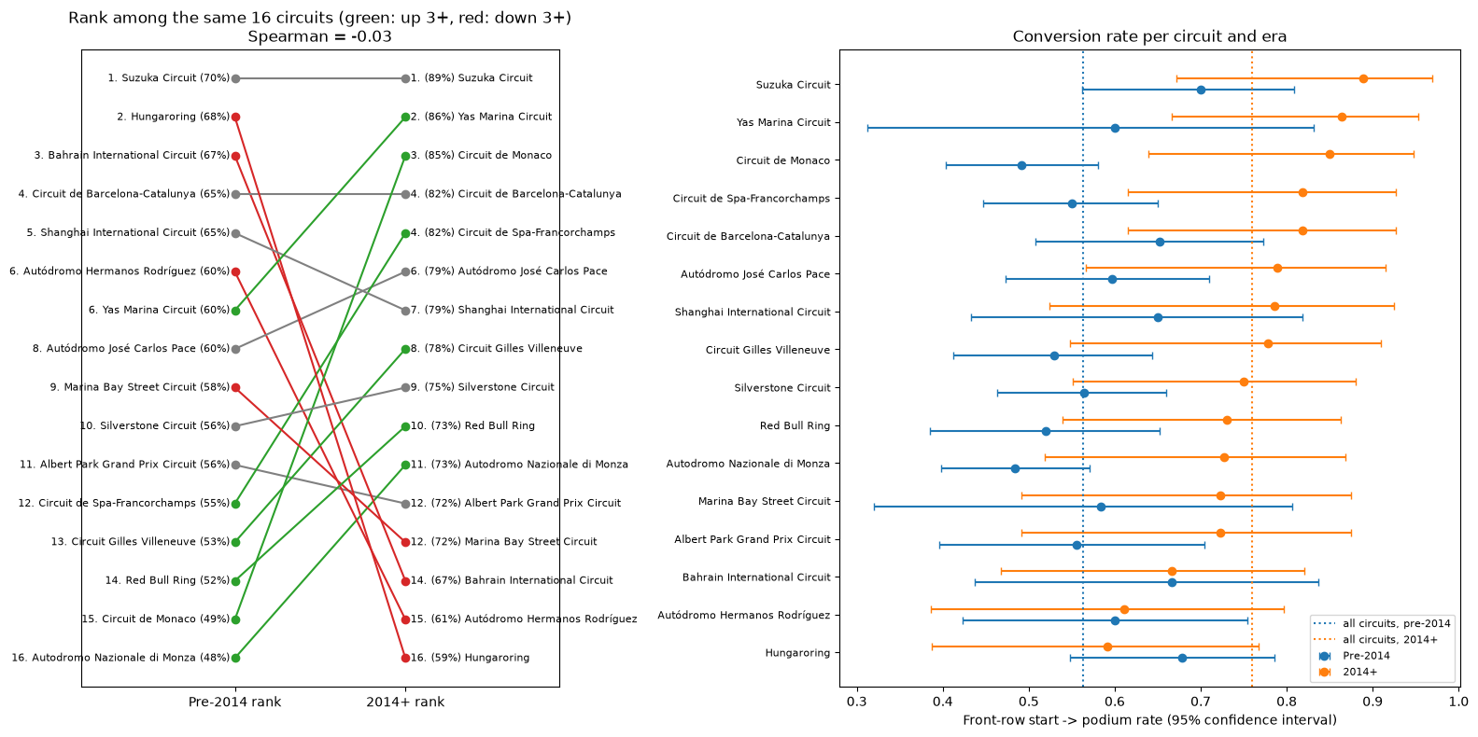
Why conversion rises after 2014. Front-row starts converted 56% of the time before 2014 and 76% from 2014. Most of the gap is reliability: 70% of front-row cars finished before 2014 against 92% after, while finishers converted at about the same rate (80% vs 83%). The rise is gradual over the decades, not a jump at the 2014 rules.
Qualifying vs grid (3.1.3). We define the front row by grid, the actual starting position after penalties. In 74 of 950 front-row starts with qualifying data the two differ. Drivers who qualified on the front row but started further back reached the podium 29% of the time, against 70% for those who started where they qualified. Ranking circuits by qualifying instead of grid gives a very similar order (Spearman 0.89).
Grain, missingness, cutoff. One row per driver per race; conversion = podiums ÷ front-row starts. grid has no missing values; qualifying exists only from 1994, so 3.1.3 uses races with qualifying records. The grid is known before the start; the finish is used only as the outcome.

Question 2: home-country podium effect
Answer. No. Once starting position is controlled for, drivers do not podium more often at home: the home-vs-away odds ratio is 0.96 (95% CI 0.81–1.14, p = 0.65).
Joins. results (grid, finish) → drivers (nationality) → races → circuits (country), plus our own nationality_country lookup, because nationality ("British") and country ("UK") use different names. home = 1 when the circuit country matches any country of the driver's nationality.
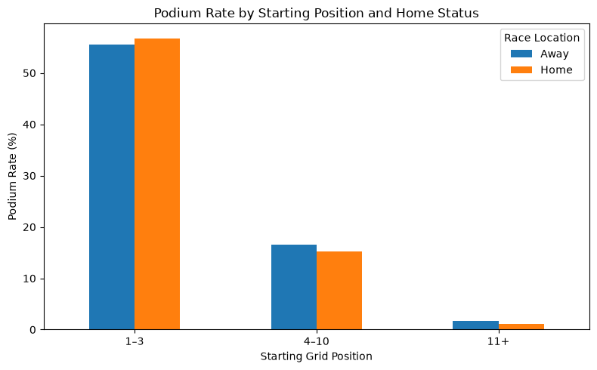
Within each grid group the differences are small and point both ways: +1.2 points from grid 1–3 (56.8% home vs 55.6% away), −1.3 points from 4–10 and −0.5 points from 11+.
Test | Home vs away odds ratio | 95% CI | p-value
Logistic regression, podium ~ home + exact grid position | 0.96 | 0.81–1.14 | 0.65
Cochran–Mantel–Haenszel, 3 grid groups | 0.93 | 0.79–1.10 | 0.42
Both intervals include 1, and they cap any hidden home advantage at about +14% higher odds. This is an association, not a causal claim: home is based on nationality, and early decades include local one-off entries.
Grain, missingness, cutoff. One row per driver per race, with a valid grid position and a known home status. Home status and grid are known before the start; the finish is used only as the outcome.

Question 3: constructor mechanical-retirement rate
Answer. Caterham had the highest mechanical-retirement rate in 2014–2021 (23.5% of starts) and Alfa Romeo in 2022–2024 (12.5%). Across all teams the rate fell from 10.2% to 6.1% of starts.
Joins and definition. results → status (why the race ended) → constructors. We grouped every status value into mechanical (engine, gearbox, hydraulics, power unit, brakes and so on) or non-mechanical (accidents, driver errors, disqualifications). Rate = mechanical retirements ÷ race starts, per constructor and period.
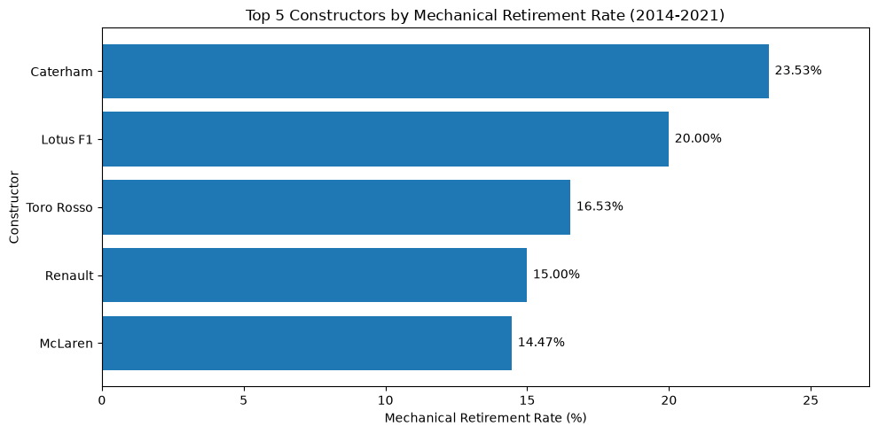
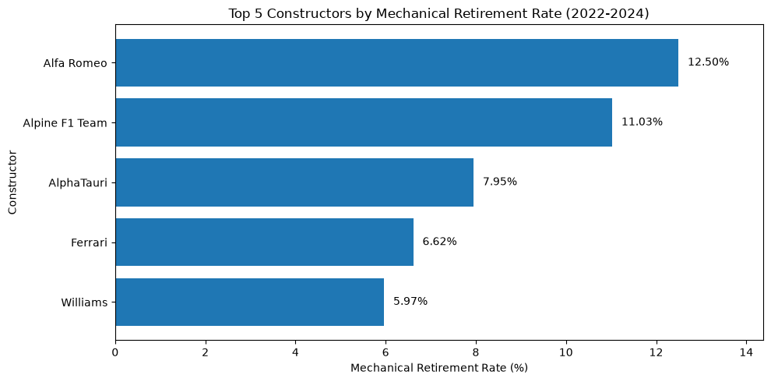
- Small samples: Caterham (34 starts) and Lotus F1 (75) raced only part of 2014–2021, so their rates are less certain than teams with 200+ starts.
- Team renames: Toro Rosso → AlphaTauri, Renault → Alpine and Sauber → Alfa Romeo each get a new constructorId, so a change between periods can be the same team under a new name.
- Sensitivity check (3.3.4): a strict mapping that moves 26 debatable statuses (punctures, wing damage, out of fuel, stalls, wheel nuts) to non-mechanical keeps the same top 5 and the same leaders in both periods. The all-team drop holds (9.5% to 5.7%).
Grain, missingness, cutoff. One row per driver per race, 2014–2024; every status maps to a type, and withdrawn drivers are excluded from starts. This is a descriptive post-race analysis: status is never a model input.

Selected features and pre-race validity
The models use 30 features in 9 groups, each known after qualifying and before the start. Starting position is the strongest single signal (Spearman about −0.46 with podium), followed by form and standings (about 0.33–0.45).
Group | Features | Source tables | Why it is valid at the pre-race cutoff
Race context | year, round, circuitId, circuit_country | races, circuits | Fixed by the calendar
Starting grid | grid_numeric, front_row, non_standard_start | results (grid only) | The grid is set before the start, after penalties
Qualifying | qualifying_position | qualifying | Qualifying happens before the race; filled with the grid before 1994
Driver attributes | driver_age, home, driver_nationality | drivers, circuits | Date of birth and nationality are fixed
Driver form | driver_starts_before, driver_podium_rate_before, last-5 and last-10 podium rate and average finish | results, earlier races only | Shifted one race back per driver (shift(1))
Driver standings | driver_points_before, driver_position_before, driver_wins_before | driver_standings | Taken from the previous round of the same season
Constructor identity | constructor_name, constructor_nationality | constructors | The team is known when the car is entered
Constructor form | constructor_races_before, last-5 and last-10 podium rate and average finish | results, earlier races only | Combined per team per race first, then shifted one race back
Constructor standings | constructor_points_before, constructor_position_before, constructor_wins_before | constructor_standings | Taken from the previous round of the same season
Leakage check. For 500 random rows we recomputed the form and standings features from scratch, using only races held before that row's race. All 500 matched, and no feature correlates close to ±1 with podium, as a post-race column would.
Excluded on purpose. Current-race position, points, laps, time, fastest-lap columns and statusId (post-race); pit_stops, lap_times and constructor_results (in-race or current-race); standings after the race; sprint_results (only from 2021); qualifying lap times (circuit-dependent, and q2/q3 mostly empty); IDs and car numbers. Two built features, grid_vs_qualifying and has_quali_data, were removed because they are almost always 0 or only flag data coverage; putting them back changes validation PR-AUC by under 0.003 (6.1).

Models, metrics and experiments
All four models beat the grid-only baseline by about 0.09 test PR-AUC and sit within 0.011 of each other. XGBoost has the best validation PR-AUC (0.640) and is the final model.
Split. Races are shuffled and divided 70/15/15 into train, validation and test by race (17,427 / 3,694 / 3,800 rows), so all drivers of a race stay together and each set covers 1950–2024 with the same podium rate. Preprocessing (median imputation with missing flags, scaling, one-hot encoding) is fitted on train only. Hyperparameters and F1 thresholds are chosen on validation; the test set is used only for reporting.
Metrics. PR-AUC is primary: podiums are 13.5% of rows, and PR-AUC measures how precisely the model finds the rare podium finishers (no-skill = 0.13). ROC-AUC is secondary: threshold-free and widely reported, but it also rewards ranking the many easy back-of-grid cases, so it stays near 0.91 for every model. F1, precision and recall use the threshold that maximises F1 on validation.
Model | Val PR-AUC | Test PR-AUC | Val ROC-AUC | Test ROC-AUC | Val F1 | Test F1 | Val precision | Test precision | Val recall | Test recall
XGBoost (final) | 0.640 | 0.593 | 0.915 | 0.909 | 0.622 | 0.597 | 0.544 | 0.523 | 0.727 | 0.696
Neural network (shallow) | 0.629 | 0.586 | 0.909 | 0.905 | 0.625 | 0.572 | 0.587 | 0.548 | 0.669 | 0.599
Random forest | 0.626 | 0.594 | 0.909 | 0.908 | 0.619 | 0.563 | 0.617 | 0.570 | 0.622 | 0.557
Logistic regression (baseline) | 0.619 | 0.597 | 0.913 | 0.908 | 0.625 | 0.592 | 0.543 | 0.521 | 0.737 | 0.686
Reference: grid only | 0.517 | 0.502 | 0.892 | 0.883 | 0.594 | 0.563 | 0.522 | 0.493 | 0.689 | 0.656
Training scores are in notebook 5.4. Random forest overfits most (train PR-AUC 0.795 vs test 0.594); XGBoost's early stopping keeps its gap at 0.086. The shallow network compared 1 layer of 32 units and 2 layers of 32-16 and 64-32, with dropout, L2 and early stopping.
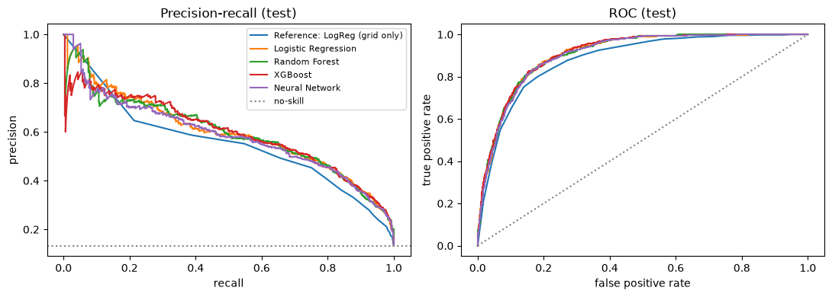
Season split (5.4.1). Trained on seasons up to 2019 and tested on 2022–2024, the statistical models reach about 0.71 test PR-AUC (no-skill 0.150). Relative to no-skill, both splits give a similar lift (about 4.7 vs 4.5). The neural network transfers worst (0.68).
Preprocessing-order experiments (5.5). Four controlled experiments with everything else fixed:
Experiment | Compared | Kept | Evidence
1. Impute vs scale order | impute → scale vs scale → impute | impute → scale | Same scores, but scale → impute leaves features off-centre (mean about −0.04, sd 0.95)
2. Log transform | scaling only vs log of skewed counts, then scaling | scaling only | Skewness drops from about 4 to under 1, but PR-AUC changes by under 0.005
3. Missing qualifying fill | grid before preprocessing vs pipeline median | grid | Median scores +0.008 val, within noise; grid is the real pre-1994 starting order
4. Class weighting | none vs balanced weights | none | Same PR-AUC; weights inflate the mean predicted probability to 0.30 against a true rate of 0.13
Feature-group ablation (6). XGBoost retrained without each of the 9 groups. Removing any single group changes test PR-AUC by about 0.01 or less, because grid and qualifying carry the same information (correlation 0.99). Removing grid and qualifying together drops test PR-AUC from 0.60 to 0.53; removing all form and standings groups together costs only 0.005.
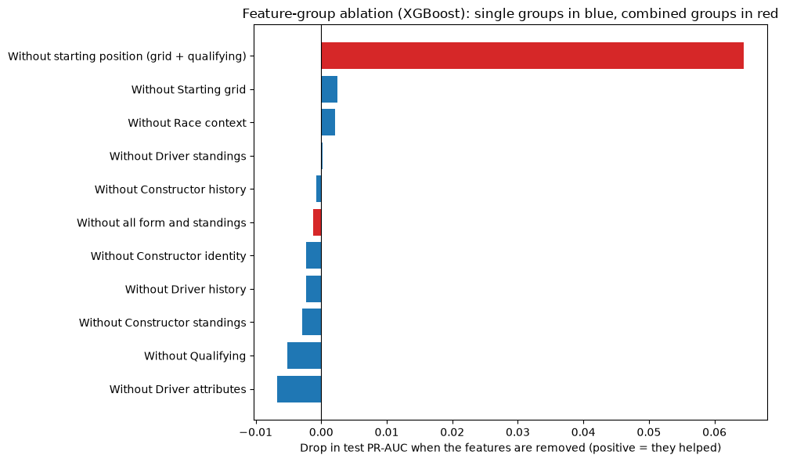
Testing the weakest features (6.1): putting back grid_vs_qualifying and has_quali_data adds under 0.001 validation PR-AUC, so they stay out; removing round, year, home and non_standard_start costs 0.003, so they stay in.

Explainability (XAI)
The final XGBoost model relies above all on starting position: shuffling grid_numeric costs about 0.10 test PR-AUC and qualifying_position about 0.04, while every other feature costs about 0.01 or less.
These explanations are not causal. A feature being important only means the model relies on it to make predictions. It does not prove the feature causes podium finishes: a good grid slot and a podium are both results of a fast car and driver.
Global: permutation importance. Each feature is shuffled 5 times on the test set and the drop in PR-AUC is measured. After the starting position come the driver's career podium rate and the constructor's recent podium rate and average finish (about 0.01 each). Values near zero or slightly negative are noise.
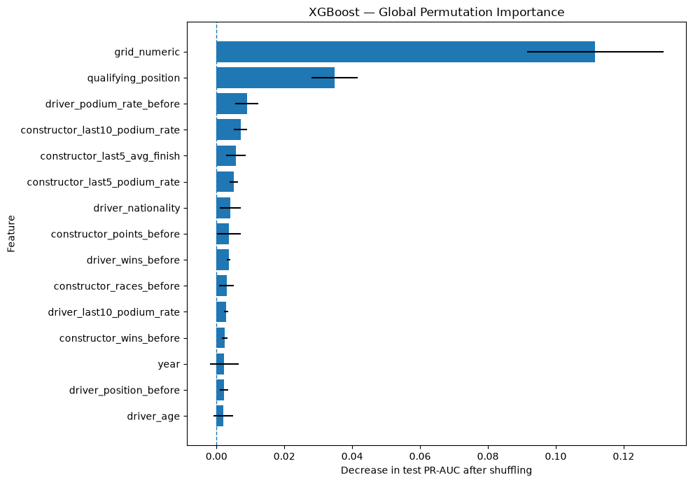
Global: SHAP. Starting position dominates (mean |SHAP| about 0.78 for both grid and qualifying): a front position pushes the prediction up by as much as +1.3 log-odds, a back position down by as much as −1.5. High recent podium rates of the driver and constructor push it up; a worse championship position before the race pushes it down.
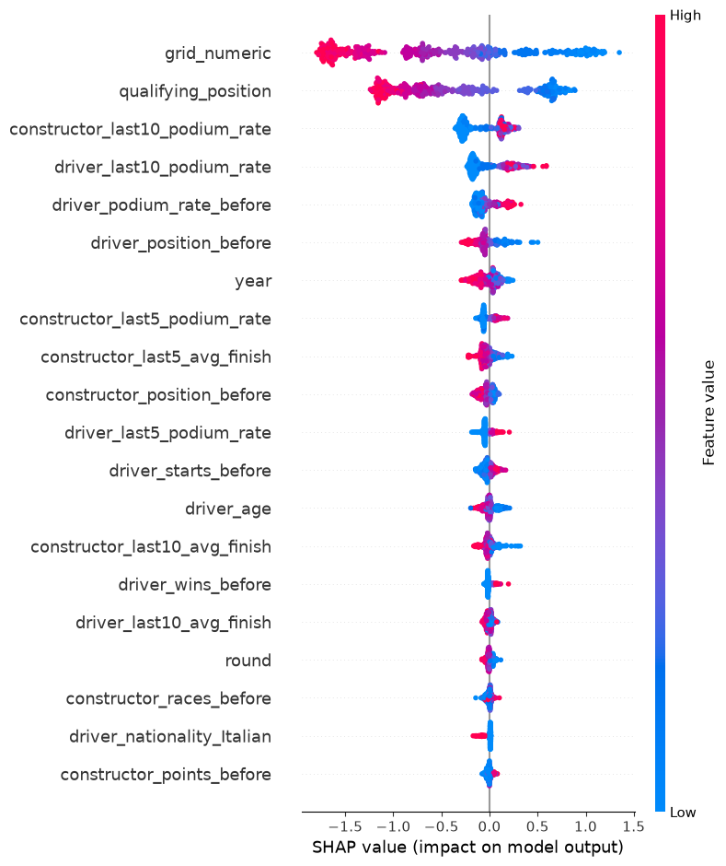
Local: Lewis Hamilton, Mercedes, 2017 Japanese GP (pole-sitter, predicted podium probability about 84%; he won). The SHAP waterfall starts from the average prediction (about 13%) and is pushed up mainly by pole position (grid +1.08, qualifying +0.72), his recent and career podium rates, Mercedes' recent results and his championship lead.
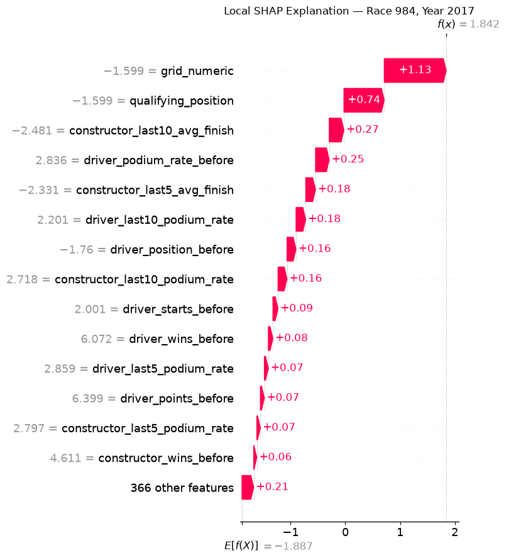
LIME fits a simple linear model around the same row and agrees that starting position matters most, followed by points, wins and recent podium rates. It also gives a little weight to the team and the circuit, which SHAP does not. LIME's weights come from random perturbations, so we treat it as a rough check and the agreement on starting position and form as the reliable part.
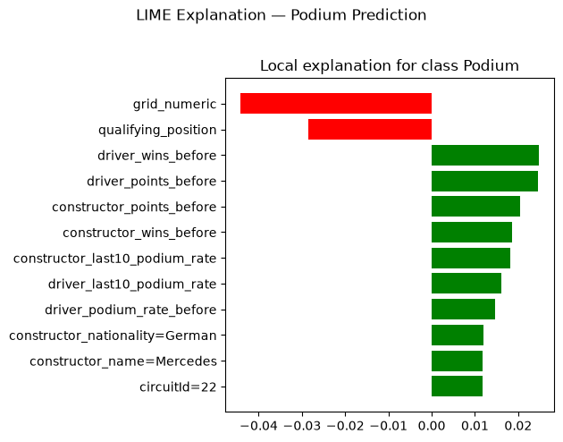

Inference function
predict_podium(record) returns a podium probability, a yes/no prediction and the list of missing features for one driver-race, and it still predicts when features are missing.
It uses the final XGBoost model and the F1 threshold chosen on validation. Missing numeric features are filled with the training median plus a missing flag, and missing categories are ignored, exactly as in training. This matters in practice: a rookie has no form or standings, and races before 1994 have no qualifying record.
Record (Max Verstappen, 2024 United States GP, grid 2) | Podium probability | Prediction | Missing features
Complete | 0.750 | Podium | none
Partially missing | 0.236 | No podium | 8: qualifying position, driver standings (3), recent driver form (4)
He did finish on the podium. Without qualifying, standings and form, the model falls back on training medians that describe an average driver, so its probability drops: with less information it is less confident, which is the intended behaviour.

Known limitations
The biggest limits are qualifying coverage before 1994 and the large changes between F1 eras; the scores are an average over 75 seasons.
- Qualifying-coverage drift. Qualifying records exist only from 1994, so for about 58% of rows the qualifying position is filled with the starting grid. Experiment 3 shows the fill barely changes the scores, but qualifying adds nothing beyond the grid for older races.
- Era sensitivity. Field sizes, reliability, points systems and regulations changed a lot. Front-row conversion was about 46–50% in the 1960s–80s against 75% in the 2010s–20s, and mechanical retirements fell from 10.2% to 6.1% of starts after 2021. XGBoost scores about 0.74 test PR-AUC on 2014–2024 races but only about 0.48 on 1950–1979 races, and it may be less accurate in a new regulation era.
- Random split vs future seasons. In the main split, training races can be later than test races. The season split (5.4.1) checks performance on unseen future seasons. Form features only look backwards in both splits.
- Shared drives (1950s). 119 rows share a finishing position with another driver, all flagged shared_drive. The swap rule held in 36 of 40 checkable cars, so a few of the 17 swap decisions may be wrong.
- Withdrawn drivers kept. 335 rows (1.3%) are drivers who withdrew; they stay with grid 0, so non_standard_start covers both pit-lane starts and non-starters.
- Missing history. About 3,000 rows have no standings before the race and newcomers have no form; these are filled with training medians, which describe an average driver.
- Home feature. home is based on nationality, not where a driver lives, and the nationality-to-country mapping is manual.
- Tuning. Hyperparameter grids are small, and early stopping uses the validation set, so validation scores are slightly optimistic; the test set is the fair comparison.
- Team identity. A renamed team (Toro Rosso → AlphaTauri, Renault → Alpine) gets a new constructorId, so its form history restarts and a brand-new team has no one-hot history.
- Explanations are not causal, and LIME varies between runs because it uses random perturbations.

